# Product Overview

HP Chromebook is a laptop with a lightweight Chrome OS that gives quick access for all your browsing needs. In today’s fast changing technology world, chromebook is a best budget device choice for educational, internet surfing, browser based training, and online meeting needs. It comes with auto update policy support.

### Quick Start Guide

1. When you switch on the chromebook, login with your gmail id
2. Chrome browser is the default installed browser
3. On the left side, there is a startup launcher with options to launch any of the standard apps installed OR the google workspace applications available through the browser with gmail account (like docs,sheets etc.)

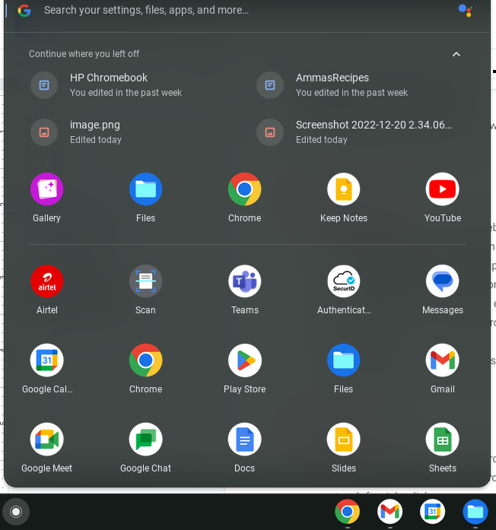

1. Toolbar has icons for Chrome browser, Gmail, Calendar, Gtalk, Gmeet, Folders, youtube, photos



1. On the right, there are standard settings, control panel options like battery, network, screen capture etc.

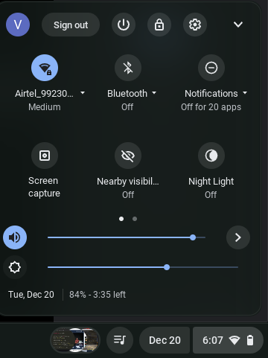

### 

### Usability Tips

* Screen Capture shortcut - Ctrl + Show Windows (6th key from left on the top panel)
* No delete button on the keyboard! - use Alt + backspace instead
* No left, right click , pointer control settings for accessibility on mousepad - use double touch for right click.
* A search button on left side on the keyboard, that shortcuts to startup menu
* My Files - Local storage on chromebook is very limited 64GB. It will get cleaned up, if the total storage capacity exceeds 80%, so remember to backup your files on the google drive instead.
* The power on/off switch has sign out, lock screen, and shutdown options.
* There are 2 ports i.e. USB port c, standard USB port, 3.5mm TRRS plug for headsets

### Working with apps

Chromebook backed by ChromeOS is designed to work with all compatible apps available on the play store. After you install the app from the play store it will appear on the bottom toolbar.

For basic needs like taking notes, editing documents, sheets etc. - the suite of apps available on google workspace - Keep Notes, Google Docs, Google sheets are available.

You may browse the play store to download the best suited app for any specific needs.

### 

### Support for upgrade

Chromebook comes with a standard OS upgrade support as per policy: <https://support.google.com/chrome/a/answer/6220366?hl=en>